**Sesi : 12 (21 Juni 2022)**

**Nama : Aldiransyah Rizky Putra**

**Kode Peserta : JVSB001ONL019**

**Nomor 1**

**Export tb_musisi (Create Table & Insert Values)**

SET NAMES utf8;

SET time_zone = '+00:00';

SET foreign_key_checks = 0;

SET sql_mode = 'NO_AUTO_VALUE_ON_ZERO';

SET NAMES utf8mb4;

DROP TABLE IF EXISTS `tb_musisi`;

CREATE TABLE `tb_musisi` (

`id_musisi` int(11) NOT NULL AUTO_INCREMENT,

`ssn` int(11) NOT NULL,

`nama_musisi` varchar(50) NOT NULL,

`alamat` varchar(50) NOT NULL,

`no_telp` varchar(50) NOT NULL,

PRIMARY KEY (`id_musisi`)

) ENGINE=InnoDB DEFAULT CHARSET=utf8mb4;

TRUNCATE `tb_musisi`;

INSERT INTO `tb_musisi` (`id_musisi`, `ssn`, `nama_musisi`, `alamat`, `no_telp`) VALUES

(1, 2313, 'Ali', 'Senopati', '086758476656'),

(2, 4244, 'Joko', 'Pondok Indah', '075736573647'),

(3, 2617, 'Ari Lasso', 'Bintaro', '0827817262716'),

(4, 2617, 'Ahmad Dhani', 'Pondok Indah', '082839262716'),

(5, 2617, 'Andra Ramadhan', 'Cempaka Putih', '-98278726172'),

(6, 2617, 'Once', 'Radio Dalam', '222222222222'),

(7, 2617, 'Pasha', 'Bintaro', '238982748372'),

(8, 2617, 'Ardhito', 'Senopati', '0827837826172'),

(9, 2617, 'Pamungkas', 'BSD', '082673627182'),

(10, 2617, 'Rossa', 'Alam Sutera', '082978261627');

**Export tb_album (Create Table & Insert Values)**

SET NAMES utf8;

SET time_zone = '+00:00';

SET foreign_key_checks = 0;

SET sql_mode = 'NO_AUTO_VALUE_ON_ZERO';

SET NAMES utf8mb4;

DROP TABLE IF EXISTS `tb_album`;

CREATE TABLE `tb_album` (

`id_album` int(11) NOT NULL AUTO_INCREMENT,

`nama_album` varchar(50) NOT NULL,

`tanggal` date NOT NULL,

`format` enum('CD','MC') NOT NULL,

`id_lagu` int(11) NOT NULL,

PRIMARY KEY (`id_album`),

KEY `id_lagu` (`id_lagu`),

CONSTRAINT `tb_album_ibfk_1` FOREIGN KEY (`id_lagu`) REFERENCES `tb_lagu` (`id_lagu`)

) ENGINE=InnoDB DEFAULT CHARSET=utf8mb4;

TRUNCATE `tb_album`;

INSERT INTO `tb_album` (`id_album`, `nama_album`, `tanggal`, `format`, `id_lagu`) VALUES

(1, 'Blue', '2000-05-02', 'CD', 2),

(2, 'Red', '2000-09-02', 'MC', 1),

(3, 'Yellow', '1998-04-03', 'CD', 1),

(4, 'Purple', '1998-04-03', '', 2),

(5, 'Black', '1998-04-03', 'CD', 1),

(6, 'White', '1998-04-03', '', 2),

(7, 'Brown', '1998-04-03', '', 2),

(8, 'Maroon', '1998-04-03', '', 1),

(9, 'Bintang 5', '1998-04-03', 'CD', 2),

(10, 'Bintang 1', '1998-04-03', 'CD', 1);

**Export tb_instrument (Create Table & Insert Values)**

SET NAMES utf8;

SET time_zone = '+00:00';

SET foreign_key_checks = 0;

SET sql_mode = 'NO_AUTO_VALUE_ON_ZERO';

SET NAMES utf8mb4;

DROP TABLE IF EXISTS `tb_instrument`;

CREATE TABLE `tb_instrument` (

`id_instrument` int(11) NOT NULL AUTO_INCREMENT,

`nama_instrument` varchar(50) NOT NULL,

`kunci` varchar(10) NOT NULL,

PRIMARY KEY (`id_instrument`)

) ENGINE=InnoDB DEFAULT CHARSET=utf8mb4;

TRUNCATE `tb_instrument`;

INSERT INTO `tb_instrument` (`id_instrument`, `nama_instrument`, `kunci`) VALUES

(1, 'Gitar', 'G#'),

(2, 'Piano', 'Ab'),

(3, 'Keyboard', 'A#'),

(4, 'Synth', 'B'),

(5, 'Cello', 'C'),

(6, 'Guitar 1', 'Bb'),

(7, 'Guitar 2', 'G#'),

(8, 'Guitar Acoustic', 'C#m'),

(9, 'Bass', 'Dm');

**Export tb_lagu (Create Table & Insert Values)**

SET NAMES utf8;

SET time_zone = '+00:00';

SET foreign_key_checks = 0;

SET sql_mode = 'NO_AUTO_VALUE_ON_ZERO';

SET NAMES utf8mb4;

DROP TABLE IF EXISTS `tb_lagu`;

CREATE TABLE `tb_lagu` (

`id_lagu` int(11) NOT NULL AUTO_INCREMENT,

`judul` varchar(50) NOT NULL,

`pengarang` varchar(50) NOT NULL,

PRIMARY KEY (`id_lagu`)

) ENGINE=InnoDB DEFAULT CHARSET=utf8mb4;

TRUNCATE `tb_lagu`;

INSERT INTO `tb_lagu` (`id_lagu`, `judul`, `pengarang`) VALUES

(1, 'Stay', 'Rahmat'),

(2, 'Hampa', 'Sanjij'),

(3, 'Teenegers', 'Ali'),

(4, 'i Dont love you', 'Gerrard Way'),

(5, 'Welcome to the black parade', 'Gerrard Way'),

(6, 'Cancer', 'MCR'),

(7, 'Smells like teen spirit', 'Nirvana'),

(8, 'Arjuna', 'Dhani'),

(9, 'Satu', 'noname'),

(10, 'Dua', 'noname');

**Export tb_musisi_album (Create Table & Insert Values)**

SET NAMES utf8;

SET time_zone = '+00:00';

SET foreign_key_checks = 0;

SET sql_mode = 'NO_AUTO_VALUE_ON_ZERO';

SET NAMES utf8mb4;

DROP TABLE IF EXISTS `tb_musisi_album`;

CREATE TABLE `tb_musisi_album` (

`id` int(11) NOT NULL AUTO_INCREMENT,

`id_musisi` int(11) NOT NULL,

`id_album` int(11) NOT NULL,

PRIMARY KEY (`id`),

KEY `id_musisi` (`id_musisi`),

KEY `id_album` (`id_album`),

CONSTRAINT `tb_musisi_album_ibfk_1` FOREIGN KEY (`id_musisi`) REFERENCES `tb_musisi` (`id_musisi`),

CONSTRAINT `tb_musisi_album_ibfk_2` FOREIGN KEY (`id_album`) REFERENCES `tb_album` (`id_album`)

) ENGINE=InnoDB DEFAULT CHARSET=utf8mb4;

TRUNCATE `tb_musisi_album`;

INSERT INTO `tb_musisi_album` (`id`, `id_musisi`, `id_album`) VALUES

(1, 2, 1),

(2, 1, 2),

(3, 4, 5),

(4, 2, 7),

(5, 6, 8),

(6, 2, 3),

(7, 2, 4),

(8, 3, 1),

(9, 3, 1),

(10, 3, 1);

**Export tb_musisi_instrument (Create Table & Insert Values)**

SET NAMES utf8;

SET time_zone = '+00:00';

SET foreign_key_checks = 0;

SET sql_mode = 'NO_AUTO_VALUE_ON_ZERO';

SET NAMES utf8mb4;

DROP TABLE IF EXISTS `tb_musisi_instrument`;

CREATE TABLE `tb_musisi_instrument` (

`id` int(11) NOT NULL AUTO_INCREMENT,

`id_musisi` int(11) NOT NULL,

`id_instrument` int(11) NOT NULL,

PRIMARY KEY (`id`),

KEY `id_musisi` (`id_musisi`),

KEY `id_instrument` (`id_instrument`),

CONSTRAINT `tb_musisi_instrument_ibfk_1` FOREIGN KEY (`id_musisi`) REFERENCES `tb_musisi` (`id_musisi`),

CONSTRAINT `tb_musisi_instrument_ibfk_2` FOREIGN KEY (`id_instrument`) REFERENCES `tb_instrument` (`id_instrument`)

) ENGINE=InnoDB DEFAULT CHARSET=utf8mb4;

TRUNCATE `tb_musisi_instrument`;

INSERT INTO `tb_musisi_instrument` (`id`, `id_musisi`, `id_instrument`) VALUES

(1, 2, 1),

(2, 1, 2),

(3, 6, 4),

(4, 2, 9),

(5, 10, 1),

(6, 3, 1),

(7, 6, 3),

(8, 9, 2),

(9, 1, 2),

(10, 5, 4);

**Export tb_musisi_lagu (Create Table & Insert Values)**

SET NAMES utf8;

SET time_zone = '+00:00';

SET foreign_key_checks = 0;

SET sql_mode = 'NO_AUTO_VALUE_ON_ZERO';

SET NAMES utf8mb4;

DROP TABLE IF EXISTS `tb_musisi_lagu`;

CREATE TABLE `tb_musisi_lagu` (

`id` int(11) NOT NULL AUTO_INCREMENT,

`id_musisi` int(11) NOT NULL,

`id_lagu` int(11) NOT NULL,

PRIMARY KEY (`id`),

KEY `id_musisi` (`id_musisi`),

KEY `id_lagu` (`id_lagu`),

CONSTRAINT `tb_musisi_lagu_ibfk_1` FOREIGN KEY (`id_musisi`) REFERENCES `tb_musisi` (`id_musisi`),

CONSTRAINT `tb_musisi_lagu_ibfk_2` FOREIGN KEY (`id_lagu`) REFERENCES `tb_lagu` (`id_lagu`)

) ENGINE=InnoDB DEFAULT CHARSET=utf8mb4;

TRUNCATE `tb_musisi_lagu`;

INSERT INTO `tb_musisi_lagu` (`id`, `id_musisi`, `id_lagu`) VALUES

(1, 2, 1),

(2, 2, 2),

(3, 4, 5),

(4, 6, 9),

(5, 5, 5),

(6, 8, 4),

(7, 3, 2),

(8, 6, 8),

(9, 2, 5),

(10, 3, 9);

**Penjelasan db_melodi_indah:**

Query diatas merupakan query yang dibuat untuk membuat tabel pada db_melodi_indah dengan memanfaatkan kata perintah CREATE. Setelah table tersebut dibuat, pemasukan data juga dilakukan sesuai dengan struktur dari masing-masing table. Query untuk memasukkan data-data tersebut dilakukan dengan menggunakan kata kunci INSERT.

Database db_melodi_indah memiliki 4 tabel yang terdiri dari tb_musisi, tb_instrument, tb_album, dan tb_lagu. Kardinalitas atau hubungan pada tabel-tabel tersebut yaitu:

1. **Many- to-many**

* **tb_musisi dan tb_instrument**

Kedua tabel ini akan menghasilkan tabel baru yang bernama tb_musisi_instrument untuk menampung foreign key dari tabel tb_musisi dan tb_instrument.

* **tb_musisi dan tb_lagu**

Kedua tabel ini akan menghasilkan tabel baru yang bernama tb_musisi_lagu untuk menampung foreign key dari tabel tb_musisi dan tb_lagu.

* **tb_musisi dan tb_album**
* Kedua tabel ini akan menghasilkan tabel baru yang bernama tb_musisi_album untuk menampung foreign key dari tabel tb_musisi dan tb_album.

1. **One-to-many**

* **Tb_album dan tb_lagu**

tb_album akan menyimpan foreign key dari table tb_lagu yaitu id_lagu.

**Nomor 2**

**Struktur db_company**

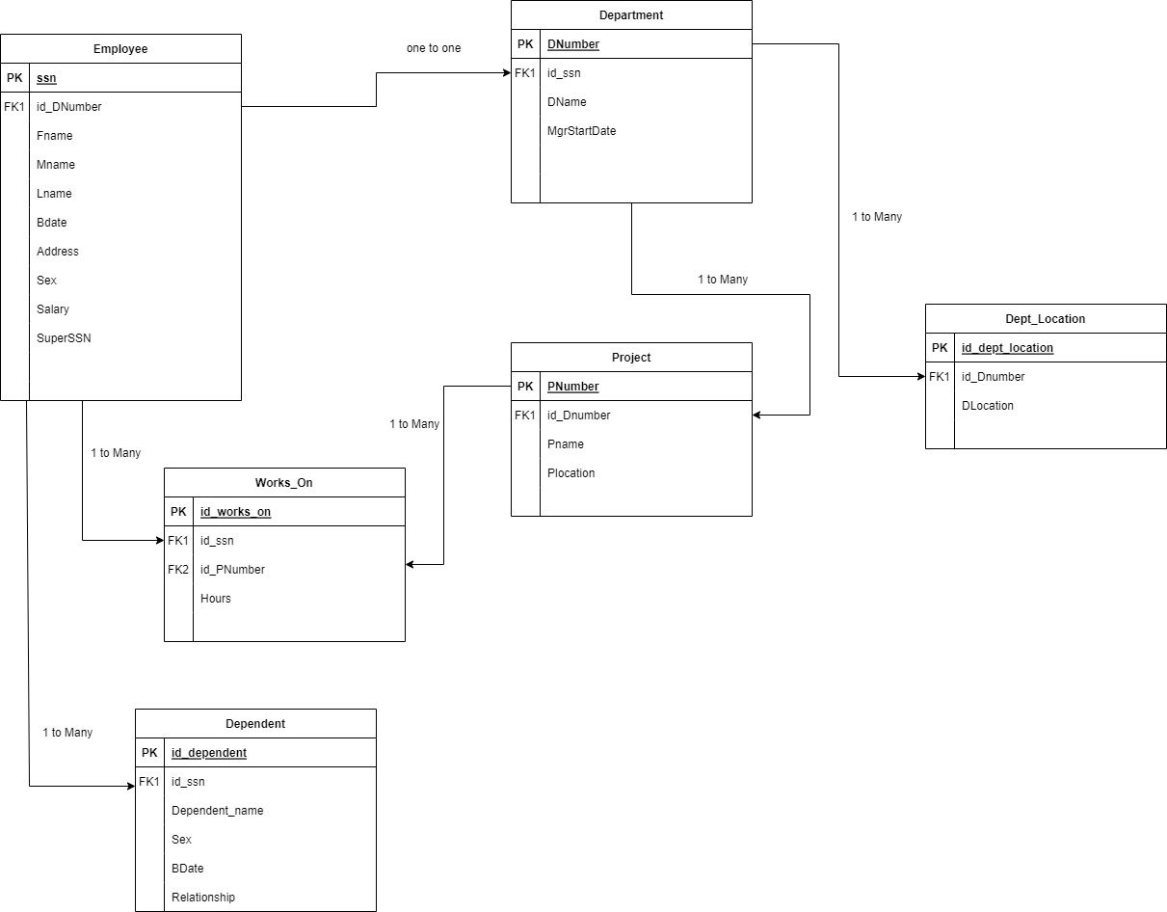

**Nomor 3**

**Query db_company**

1. **Tampilkan dependent_name dan relationship dengan employee yang namanya diawali huruf R?**

[**select**](https://mariadb.com/kb/en/library/select/) td.dependent_name, td.relationship, te.Fname as 'nama' from [tb_employee](http://localhost/adminer/?server=localhost&username=root&db=db_company&table=tb_employee) te  
[**join**](https://mariadb.com/kb/en/library/join/) [tb_dependent](http://localhost/adminer/?server=localhost&username=root&db=db_company&table=tb_dependent) td on te.ssn = td.ssn   
where te.Fname [**like**](https://mariadb.com/kb/en/library/string-comparison-functions/#operator_like) 'R%';

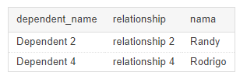

1. **Banyaknya employee yang mengerjakan project PNum = 1 ?**

[**select**](https://mariadb.com/kb/en/library/select/) [**count**](https://mariadb.com/kb/en/library/group-by-functions/#function_count)(te.ssn) as 'Jumlah Employee', tw.Pnumber from [tb_works_on](http://localhost/adminer/?server=localhost&username=root&db=db_company&table=tb_works_on) tw  
[**join**](https://mariadb.com/kb/en/library/join/) [tb_employee](http://localhost/adminer/?server=localhost&username=root&db=db_company&table=tb_employee) te on te.ssn = tw.ssn  
where Pnumber = 1;

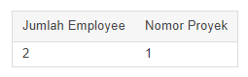

1. **Banyaknya employee yang memiliki salary lebih dari 3500000?**

[**select**](https://mariadb.com/kb/en/library/select/) [**count**](https://mariadb.com/kb/en/library/group-by-functions/#function_count)(ssn) as 'Jumlah Employee' from [tb_employee](http://localhost/adminer/?server=localhost&username=root&db=db_company&table=tb_employee)  
where salary > 3500000;

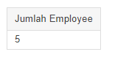

1. **Banyaknya project yang dikerjakan DNum = 2 ?**

[**select**](https://mariadb.com/kb/en/library/select/) [**count**](https://mariadb.com/kb/en/library/group-by-functions/#function_count)(Pnumber) as 'Jumlah proyek' from [tb_project](http://localhost/adminer/?server=localhost&username=root&db=db_company&table=tb_project)  
where Dnumber = 2;

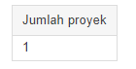

1. **Hitung total dan rata-rata salary dari setiap department?**

[**select**](https://mariadb.com/kb/en/library/select/) [**sum**](https://mariadb.com/kb/en/library/group-by-functions/#function_sum)(te.salary) as 'Total Salary', [**avg**](https://mariadb.com/kb/en/library/group-by-functions/#function_avg)(te.salary) as 'Rata-rata Salary', td.Dname as 'Nama Department' from [tb_employee](http://localhost/adminer/?server=localhost&username=root&db=db_company&table=tb_employee) te  
[**join**](https://mariadb.com/kb/en/library/join/) [tb_department](http://localhost/adminer/?server=localhost&username=root&db=db_company&table=tb_department) td on td.ssn = te.ssn  
group by td.Dname;

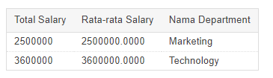

1. **Banyaknya employee dari setiap department dan urutkan berdasarkan employee terbanyak?**

[**select**](https://mariadb.com/kb/en/library/select/) [**count**](https://mariadb.com/kb/en/library/group-by-functions/#function_count)(te.ssn) as "total_employee", td.Dname from [tb_employee](http://localhost/adminer/?server=localhost&username=root&db=db_company&table=tb_employee) te  
[**join**](https://mariadb.com/kb/en/library/join/) [tb_department](http://localhost/adminer/?server=localhost&username=root&db=db_company&table=tb_department) td on te.Dnumber = td.Dnumber  
Group by td.Dname  
Order by [**count**](https://mariadb.com/kb/en/library/group-by-functions/#function_count)(te.ssn) desc;

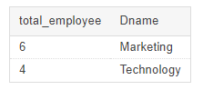

1. **Total hours perweek dari semua employee untuk setiap department?**

Catatan : Karena bingung dengan ‘perweek’ saya hanya menampikan total saja.

[**select**](https://mariadb.com/kb/en/library/select/) te.fname as 'name' , [**sum**](https://mariadb.com/kb/en/library/group-by-functions/#function_sum)(tw.hours) as 'total_jam_kerja' from [tb_employee](http://localhost/adminer/?server=localhost&username=root&db=db_company&table=tb_employee) te  
[**join**](https://mariadb.com/kb/en/library/join/) [tb_works_on](http://localhost/adminer/?server=localhost&username=root&db=db_company&table=tb_works_on) tw on te.ssn = tw.ssn  
group by te.fname;

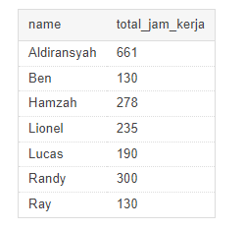

1. **Employee yang memiliki total hours perweek lebih besar dari 140 hours dan urutkan berdasarkan jumlah jam kerja terbanyak?**

[**select**](https://mariadb.com/kb/en/library/select/) te.fname as 'name' , [**sum**](https://mariadb.com/kb/en/library/group-by-functions/#function_sum)(tw.hours) as 'total_jam_kerja' from [tb_employee](http://localhost/adminer/?server=localhost&username=root&db=db_company&table=tb_employee) te  
[**join**](https://mariadb.com/kb/en/library/join/) [tb_works_on](http://localhost/adminer/?server=localhost&username=root&db=db_company&table=tb_works_on) tw on te.ssn = tw.ssn  
group by te.fname  
having [**sum**](https://mariadb.com/kb/en/library/group-by-functions/#function_sum)(tw.hours) > 140 ;  
order by [**sum**](https://mariadb.com/kb/en/library/group-by-functions/#function_sum)(tw.hours) desc;

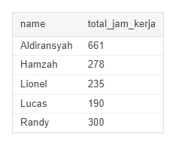

1. **Kelompokan bonus employee berdasarkan jam kerjanya ? (jika >= 200 hours, maka bonus = 50%. Jika >=150 hours, maka bonus = 25%, selainnya bonus 10%)**

[**select**](https://mariadb.com/kb/en/library/select/) te.Fname as 'name', tw.hours as 'jam_kerja',  
**case**  
 when tw.hours >= 200 then '50%'  
 when tw.hours >= 150 then '25%'  
 else '10%'  
[**end**](https://mariadb.com/kb/en/library/begin-end/) as Bonus  
from [tb_employee](http://localhost/adminer/?server=localhost&username=root&db=db_company&table=tb_employee) te   
[**join**](https://mariadb.com/kb/en/library/join/) [tb_works_on](http://localhost/adminer/?server=localhost&username=root&db=db_company&table=tb_works_on) tw  
on te.ssn = tw.ssn;

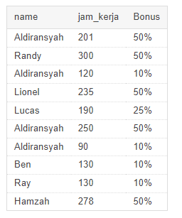

1. **Banyaknya project yang dikerjakan tiap employee dan urutkan dari yang terbanyak.**

[**select**](https://mariadb.com/kb/en/library/select/) te.Fname as 'name', [**count**](https://mariadb.com/kb/en/library/group-by-functions/#function_count)(tw.Pnumber) as 'jumlah_proyek'from [tb_employee](http://localhost/adminer/?server=localhost&username=root&db=db_company&table=tb_employee) te  
[**join**](https://mariadb.com/kb/en/library/join/) [tb_works_on](http://localhost/adminer/?server=localhost&username=root&db=db_company&table=tb_works_on) tw on te.ssn = tw.ssn  
group by te.Fname  
order by [**count**](https://mariadb.com/kb/en/library/group-by-functions/#function_count)(tw.Pnumber) desc;

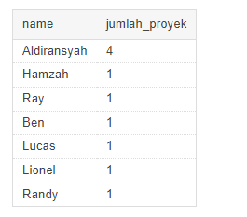

1. **Employee yang bekerja pada 4 project?**

[**select**](https://mariadb.com/kb/en/library/select/) te.Fname as 'name', [**count**](https://mariadb.com/kb/en/library/group-by-functions/#function_count)(tw.Pnumber) as 'jumlah_proyek'from [tb_employee](http://localhost/adminer/?server=localhost&username=root&db=db_company&table=tb_employee) te  
[**join**](https://mariadb.com/kb/en/library/join/) [tb_works_on](http://localhost/adminer/?server=localhost&username=root&db=db_company&table=tb_works_on) tw on te.ssn = tw.ssn  
group by te.Fname  
having [**count**](https://mariadb.com/kb/en/library/group-by-functions/#function_count)(tw.Pnumber) >= 4;

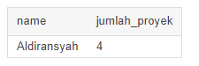

1. **Employee yang memiliki rata-rata hours perweek = 70 jam dan bekerja pada 2 project?**

[**select**](https://mariadb.com/kb/en/library/select/) te.Fname as 'nama' , [**avg**](https://mariadb.com/kb/en/library/group-by-functions/#function_avg)(tw.hours) as 'rata-rata jam', [**count**](https://mariadb.com/kb/en/library/group-by-functions/#function_count)(tw.Pnumber) as 'jumlah proyek' from [tb_employee](http://localhost/adminer/?server=localhost&username=root&db=db_company&table=tb_employee) te  
[**join**](https://mariadb.com/kb/en/library/join/) [tb_works_on](http://localhost/adminer/?server=localhost&username=root&db=db_company&table=tb_works_on) tw on te.ssn = tw.ssn  
group by tw.Pnumber  
having [**count**](https://mariadb.com/kb/en/library/group-by-functions/#function_count)(tw.Pnumber) = 2;

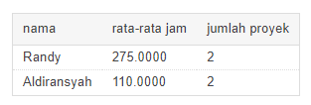

1. **Banyaknya dependent berdasarkan relationship dengan employee?**

[**select**](https://mariadb.com/kb/en/library/select/) [**count**](https://mariadb.com/kb/en/library/group-by-functions/#function_count)(td.id_dependent) as 'dependent', te.fname as 'name' from [tb_dependent](http://localhost/adminer/?server=localhost&username=root&db=db_company&table=tb_dependent) td  
[**join**](https://mariadb.com/kb/en/library/join/) [tb_employee](http://localhost/adminer/?server=localhost&username=root&db=db_company&table=tb_employee) te on td.ssn = te.ssn  
group by te.fname

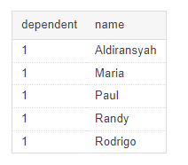

1. **Berapa lama Manager tiap department sudah menjabat?**

[**select**](https://mariadb.com/kb/en/library/select/) ssn as 'nomor_SSN', [**datediff**](https://mariadb.com/kb/en/library/date-and-time-functions/#function_datediff)('2022-06-21', MgrStartDate ) as 'lama_menjabat' from [tb_department](http://localhost/adminer/?server=localhost&username=root&db=db_company&table=tb_department)  
order by ssn asc;

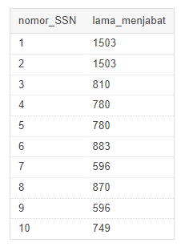

1. **Lokasi project yang menjadi tempat lebih dari satu department?**

[**select**](https://mariadb.com/kb/en/library/select/) tp.Plocation as 'lokasi', [**count**](https://mariadb.com/kb/en/library/group-by-functions/#function_count)(td.Dnumber) as 'Jumlah' from [tb_department](http://localhost/adminer/?server=localhost&username=root&db=db_company&table=tb_department) td  
[**join**](https://mariadb.com/kb/en/library/join/) [tb_project](http://localhost/adminer/?server=localhost&username=root&db=db_company&table=tb_project) tp on tp.Dnumber = td.Dnumber  
group by td.Dnumber  
having [**count**](https://mariadb.com/kb/en/library/group-by-functions/#function_count)(td.Dnumber) > 1;

